## 4.6. User Interface Design

### 4.6.1 HomeController

#### 4.6.1.1 Index

#### 

Figure 4. 8 – Index

|  |  |  |  |  |  |
| --- | --- | --- | --- | --- | --- |
| **No.** | **Object/ Control Name** | **Object/ Control Name in English** | **Type** | **Required** | **Description** |
| 1 | Tên công việc | JobName | Text | Y |  |
| 2 | Mức lương | Salary | Text | N/A |  |
|  |  |  |  |  |  |

### 4.6.2 AccountController

#### 4.6.2.1 Login

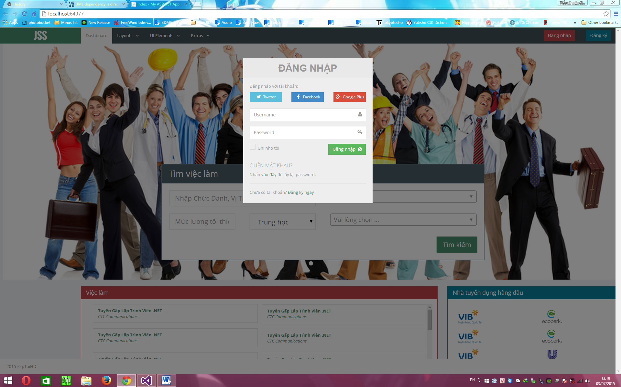

Figure 4. 9 - Login

### 4.6.3 ApplicantController

#### 4.6.3.1 List

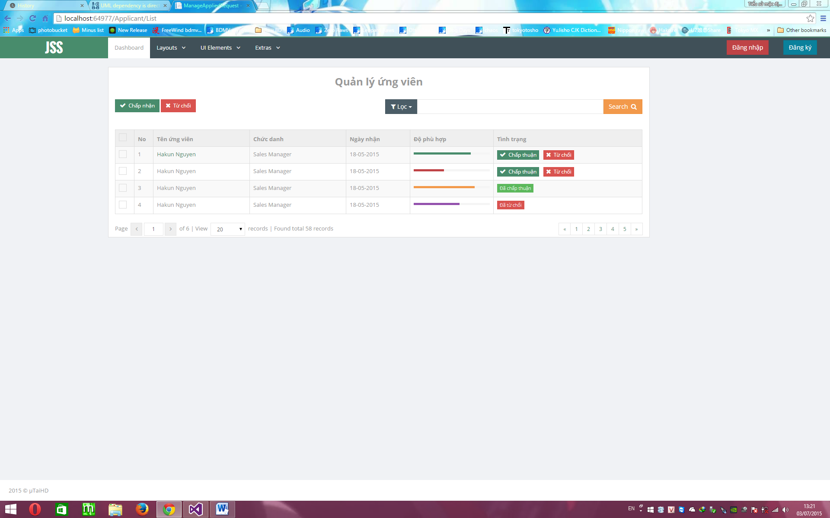

Figure 4. 10 - List

### 4.6.4 JobController

#### 4.6.4.1 Find

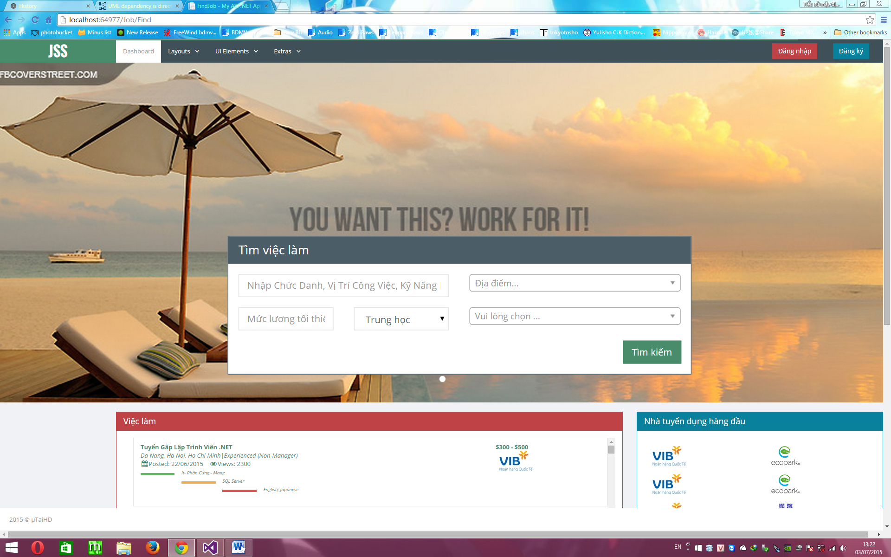

Figure 4. 11 - Find

#### 4.6.4.2 Create

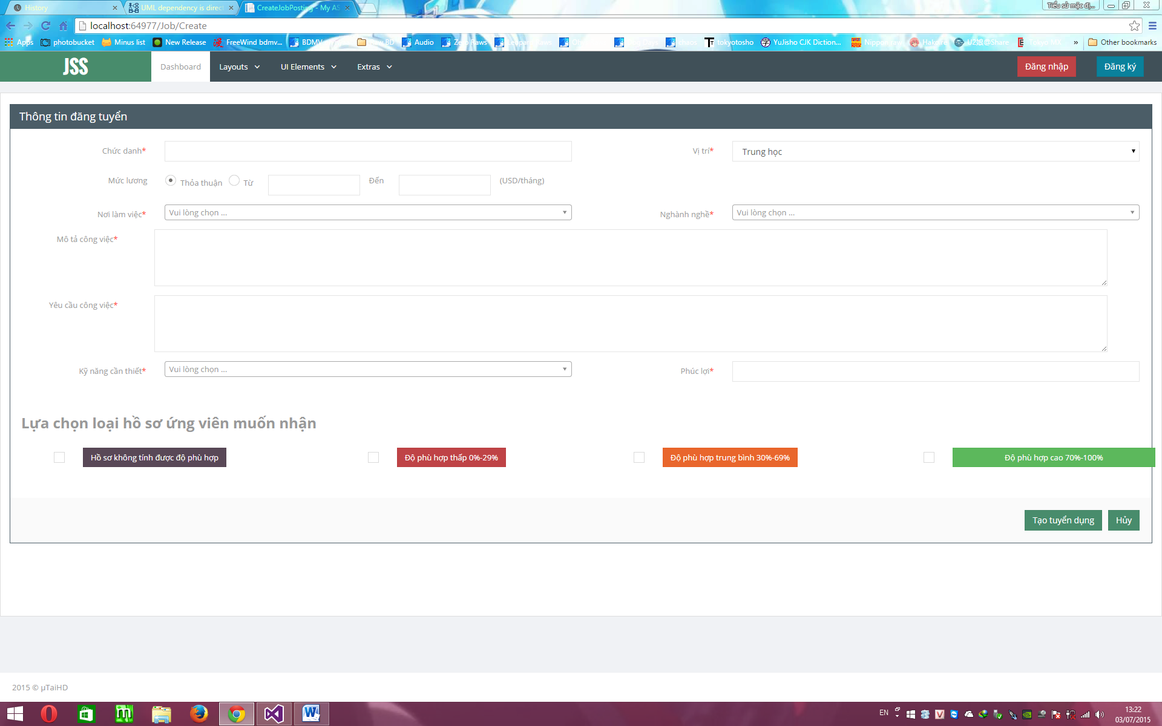

Figure 4. 12 - Create

#### 4.6.4.3 Detail

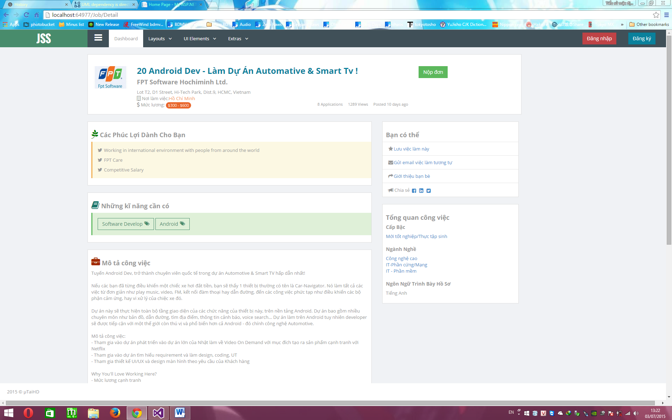

Figure 4. 13 - Detail

#### 4.6.4.4 OwnList

Figure 4. 14 - OwnList

#### 4.6.4.5 AppliedJobList

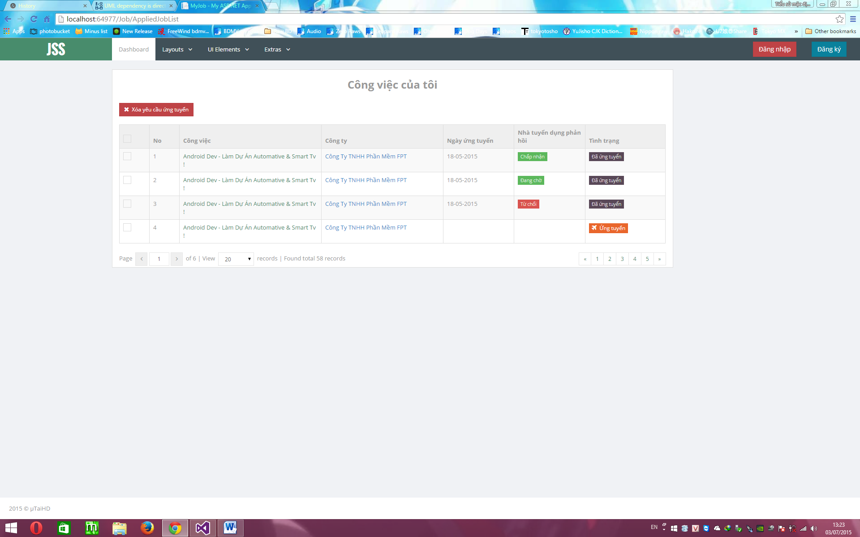

Figure 4. 15 - AppliedJobList

### 4.6.5 JobPackageController

#### 4.6.5.1 Choose

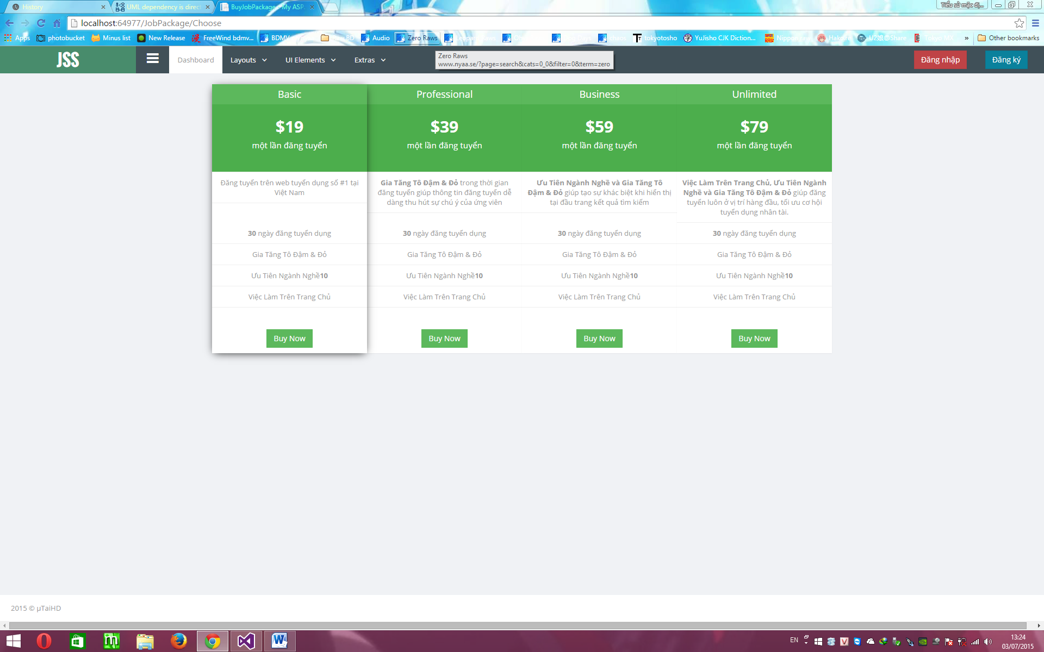

Figure 4. 16 - Choose

#### 4.6.5.2 Invoice

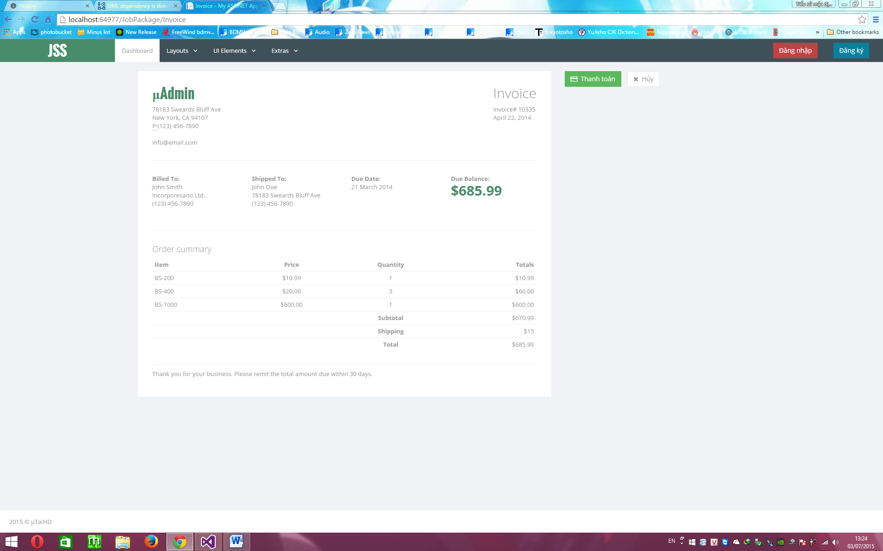

Figure 4. 17 - Invoice

### 4.6.6 MessageController

#### 4.6.6.1 Inbox

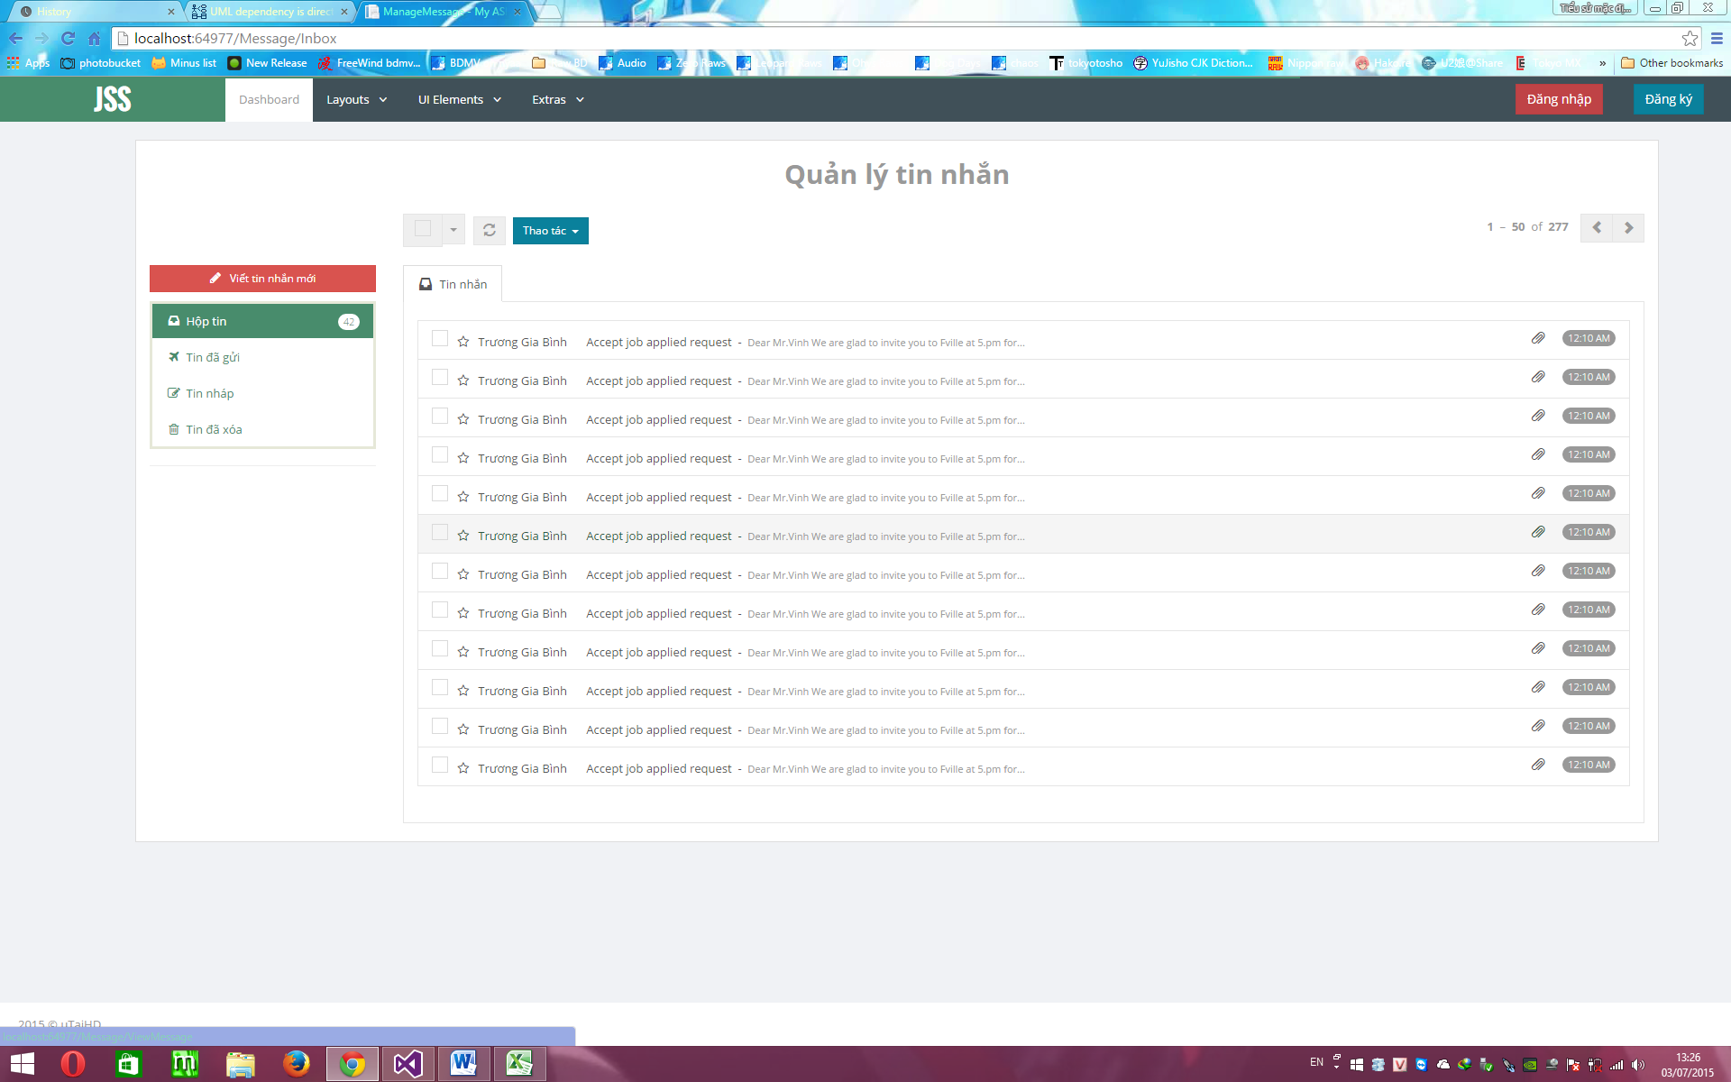

Figure 4. 18 - Inbox

#### 4.6.6.2 Detail

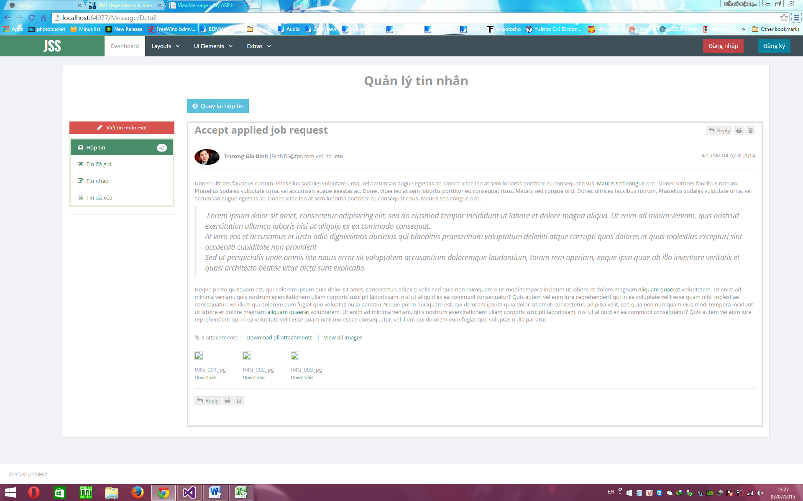

Figure 4. 19 - Detail

### 4.6.7 ProfileController

#### 4.6.7.1 List

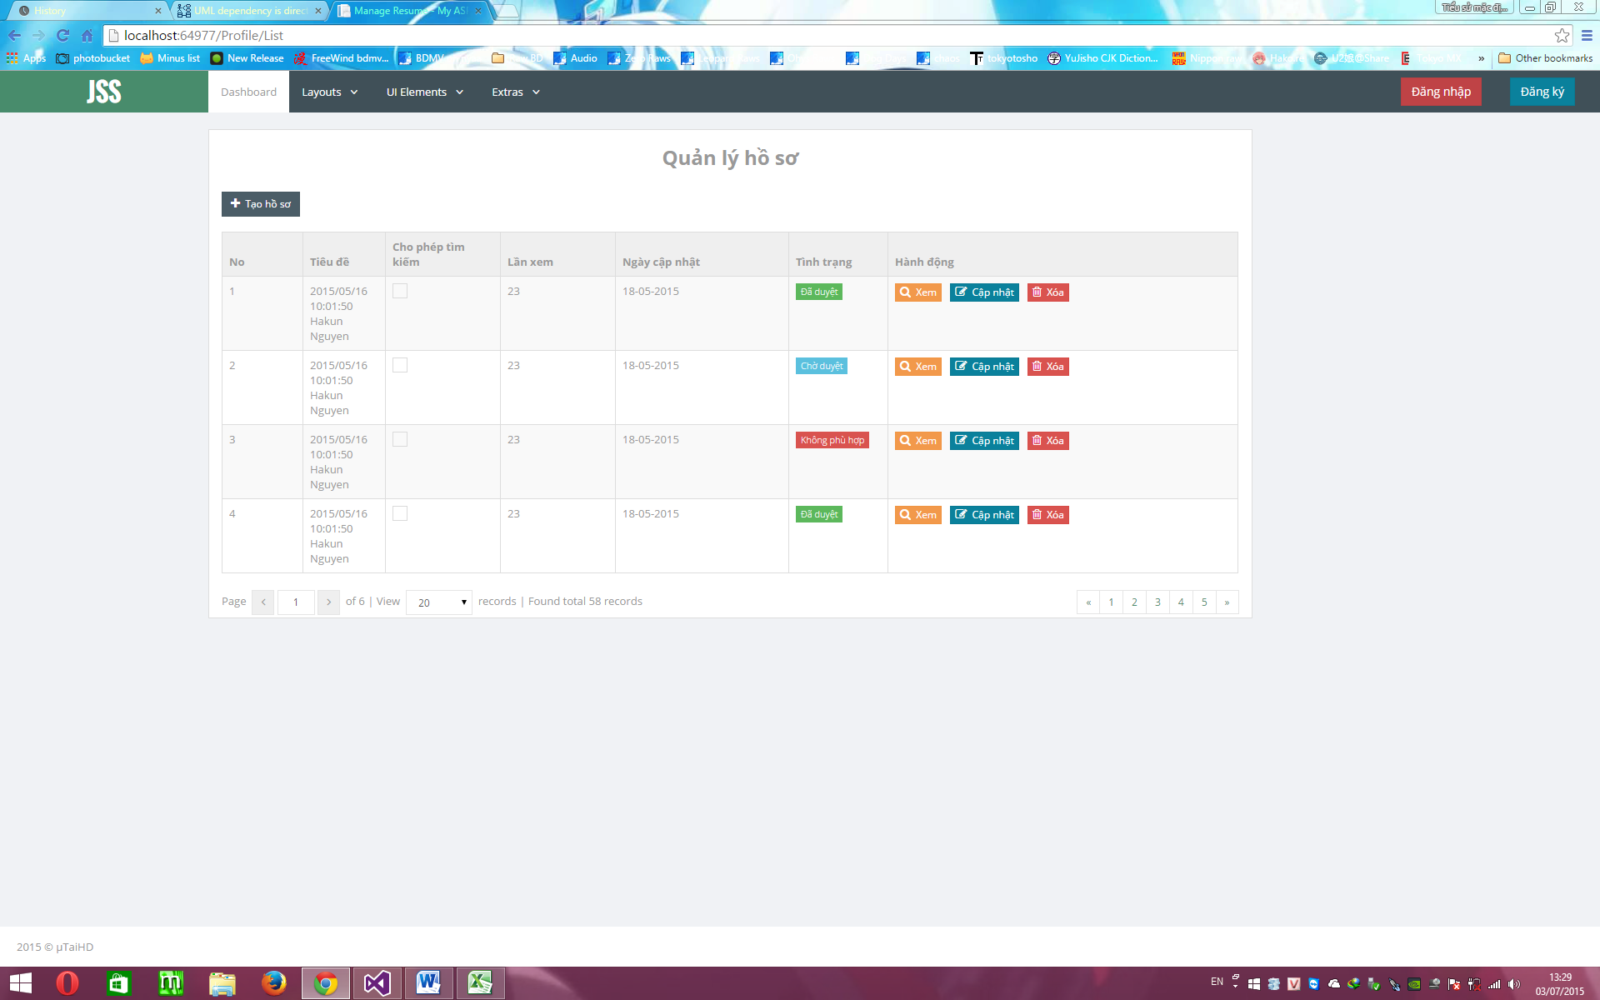

Figure 4. 20 - List

#### 4.6.7.2 Create

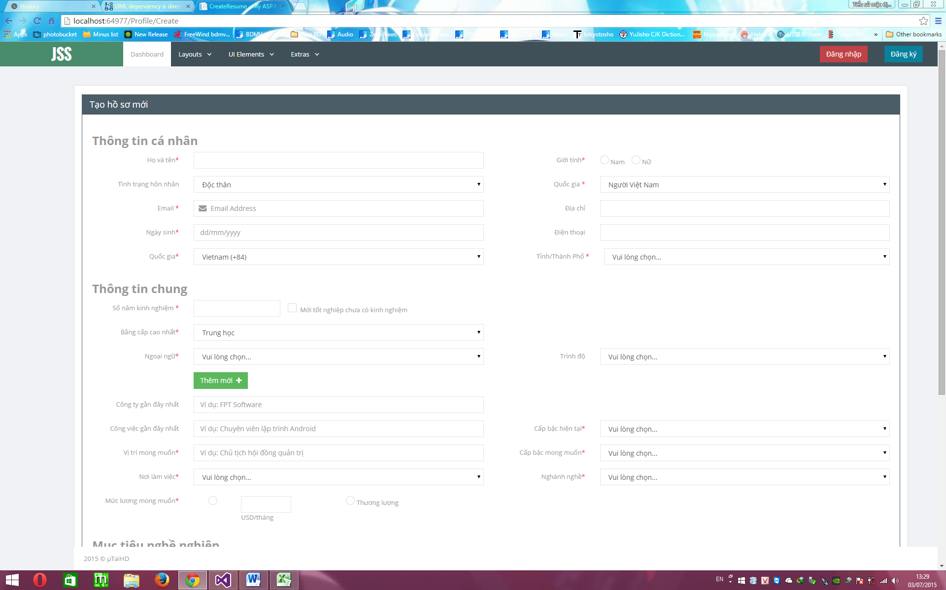

Figure 4. 21 - Create

### 4.6.8 TopicController

#### 4.6.8.1 List

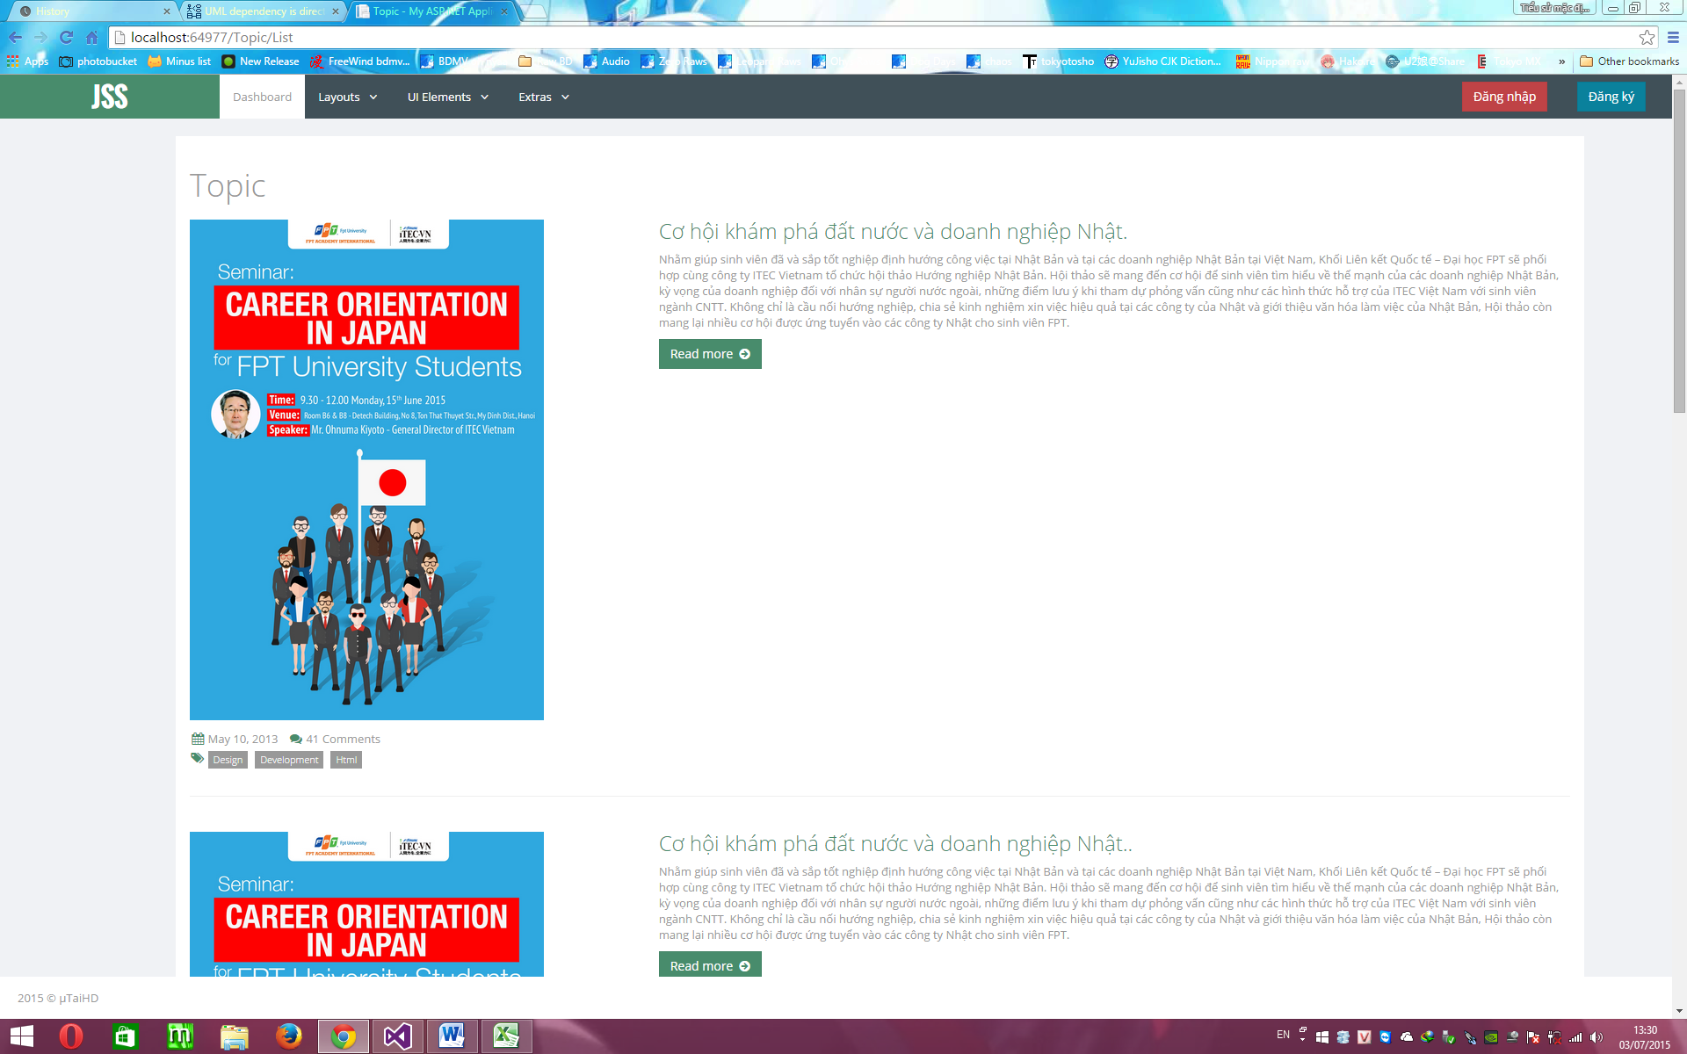

Figure 4. 22 - List

#### 4.6.8.2 Create

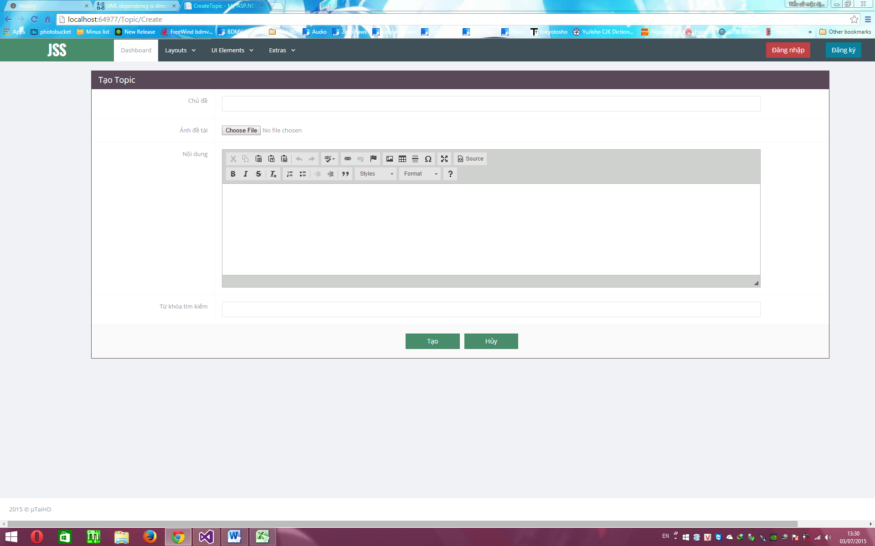

Figure 4. 23 - Create

#### 4.6.8.3 Detail

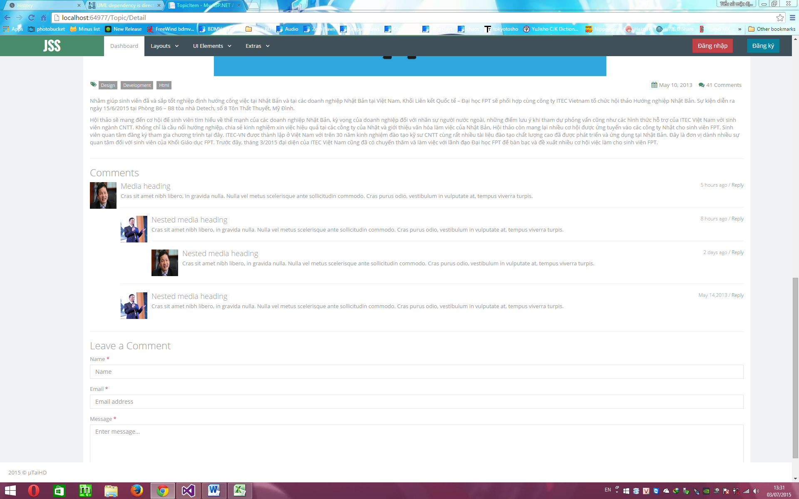

Figure 4. 24 - Detail